Methodology

Parametric approach

In the project several univariate models were used to specify the volatility dynamics of SMI returns series.

The GARCH models were thought as an extension of ARCH models (Bollerslev 1986). The standard GARCH (1,1) was one of the models used in this project. In this model, the conditional variance of returns is constructed as:

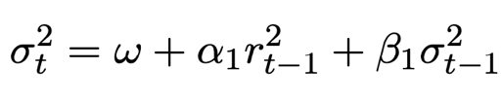

It depends on a constant term, last observation of squared returns and previous conditional variance. It is easily to see that this model is able to take into account the clustering phenomenon, where high (low) volatility tends to be followed by high (low) volatility in the next period. Empirical evidence suggests that the specification GARCH (1,1) is suitable for explaining financial data series. It can be shown that the ARCH ($∞$) can be replaced with a GARCH (1,1), respecting the parsimonious principle.

It is covariance stationarity if $α+β<1$ and to assure $σ_{t}^{2}>0$, $ω; α; β≥0.$

However, this model is uncapable of taking into consideration the leverage effect on today’s volatility, as empirical evidence suggests volatility increases when past returns are negative. In Standard GARCH, good and bad news have the same effect on volatility.

This inconvenient was solved by the GJR-GARCH (1,1) model. In this specification, a new term is added to explain returns volatility where it will enter in the equation to increase volatility only when past returns are negative, assigning asymmetrical treatment to the sign of previous returns. The dynamic equation of a GJR (1,1) for the conditional variance is given by:

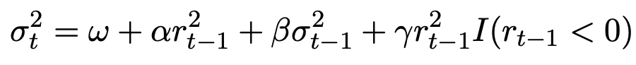

The last term becomes operative only when past returns are negative ($I=1 if r_{t-1}<0;I=0 if r_{t-1}>0)$, adding extra volatility to the original specification in the Standard GARCH. For covariance stationarity, is needed: ($α+β+\frac{γ}{2})<1$.

In addition, there were used another set of models which include macroeconomic variables in the dynamic equation of conditional variance. The idea behind is that macroeconomic variables indicators can influence financial asset prices because of expectations or macro analysis. The problem of including MV (macroeconomic variables) is that these are observed in a lower frequency than daily returns.

The univariate GARCH-MIDAS (MIxed DAta Sampling) model includes macroeconomic variables. The problem of different frequency on observations is solved by decomposing the dynamic equation into a short-term component depending on past squared returns observations and past value of the short-term component, and a long-term component depending on a constant variable and the macroeconomic variable. The model is defined as:

Where:

$r_{i,t}:represents the\log{return for day i of the period t }$

$N_{t}:is the number of days for period t$

$z_{i,t}| F_{i,t} \sim N \left(0,1\right) where F_{i,t} denotes the information set up to day i-1 of period t$

$g_{i,t} follows a unit mean reverting GARCH \left(1,1\right) process (short run component)$

$τ_{t}:provides the slow moving average level of volatility (long run component)$

The short run component is given by:

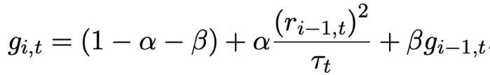

While the long run component is defined as:

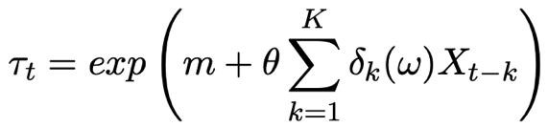

Where:

m is the intercept

$θ:$ the coefficient to estimate

$δ_{k }(w)$: function that weighs past K realizations of $X_{t }$

The Beta function is defined by:

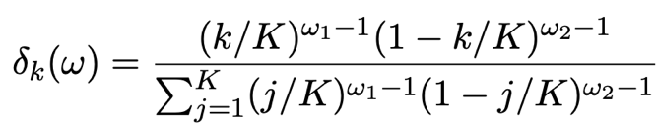

If $ω_{1}< ω_{2}$ recent observations weigh more in the long-term component.

We assume $X_{t }$ is independent of $z_{i,t}$ and that is strictly stationary.

In our project, we estimated this model with three different macroeconomic variables: Real GDP, Unemployment Rate and 10-years Bond Yields.

The drawbacks of this model is that is does not considers the leverage effect for past negative returns and bad macroeconomic news.

The Double Asymmetric GARCH MIDAS (DAGM), proposed by Amendola (2019), is the model that includes macroeconomic variables as an explanatory determinant and the effect of past negative returns and macroeconomic indicators.

Short-run component is given by:



Where the term determined by the coefficient $γ$ become operative in case past returns are negative (increasing volatility).

Long-run component is defined as:



Where different weighs are given to past macroeconomic variable whether they took negative or positive values.

Non-parametric approach

In the non-parametric models, we do not make any assumption on the distribution of daily returns, and we do not have to estimate any parameter.

The most known method of this approach is the Historical Simulation (Hendricks (1996)) method, which was implemented in the project for calculating the ${VaR}_{τ,t}$ based on the sample quantile for a fixed rolling window of data. This means calculating using a fixed number of previous observations and using it as a forecast. The window length (w) is fixed and is updated from the newest observation.

Even though this model does not need assumptions on daily returns distribution, it needs that returns entering the moving window must be independent and identically distributed (iid).

VaR is estimated as:

$${{\hat{VaR}}^{w}}_{τ,t}={\hat{Q}}_{r_{τ,t}}(τ)$$

Where $r_{τ,t}$ represents the daily returns that are included in the length for the sample used in the calculations. And ${\hat{Q}}_{r_{τ,t}}(τ)$ is the sample quantile at $τ$ level.

The problem is that this model needs a large window to get an accurate estimation, but it increases the chances of returns not respecting the previous assumption (less likely to be iid) and the estimator would be bad as structural breaks could happen.

In the project, the length of the rolling window was set at 250 observations.

Semi-parametric approach

This kind of approach also uses quantiles regression for the ${VaR}_{τ,t}$ estimation as we directly estimate it by using the $τ$-th sample quantile (${\hat{Q}}_{r_{τ,t}}(τ)$)

The Quantile Linear ARCH model (Koenker and Zhao-1996) uses this logic of approach, where the ${VaR}_{τ,t}$ is directly calculated and is defined as:



One difference from the original ARCH model is that, instead of lagged squared returns, the semi-parametric approach uses past absolute returns.

The rest of the semi-parametric approach models are different specifications of the CAViaR model (Engle and Manganelli-2004), where ${VaR}_{τ,t}$ is estimated using previous estimations of it (${VaR}_{τ,t-i}$) and past returns observations introduced using its absolute value. Three different specifications were used for our project.

The CAViaR-Symmetric Absolute Value (CAViaR-SAV) is defined as:



The VaR at level $τ$ depends on most recent VaR estimation and recent observation of absolute returns.

The CAViaR-Indirect GARCH (CAViaR-IG) is similar to the specification from above: instead of past absolute returns, it uses past squared returns, and squared ${VaR}_{τ,t-1}$ instead. It follows the next specification:

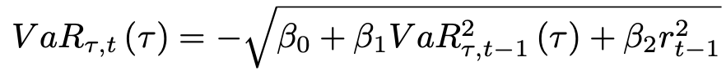

One drawback from these two previous models is that positive and negative returns have the same treatment. This means that they are not able to model the Leverage Effect, which can be solved with the CAViaR-Assymetric Slope (CAViaR-AS), defined as:



This model allows us to give different relevance to past returns depending on whether they took positive or negative values.

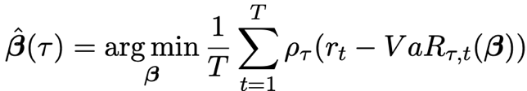Parameters from CAViaR models are estimated by minimizing the following quantile loss function:

Empirical analysis:

Data Analysis

Once we transformed our data set into a time series, we evaluated the characteristics of the Swiss Stock Market Index (SSMI) series from 01/01/2000 to 31/12/2020. We focus our data analysis using the main tests for evaluating the stylized facts.

Autocorrelograms

We started by evaluating the autocorrelation function (ACF). The ACF is a function where daily returns depend on past returns observations. In this test, we want to see whether previous observations are correlated with today’s observation, and we test for each individual correlation coefficient. So, our null hypothesis is that there is no correlation with past returns $(ρ=0)$, coefficients accompanying lagged returns are equal to zero. But, if we reject H0, is because the lagged return is statistically significant and different to zero. Meaning that, the lagged return is significant to explain daily returns and we should take it into account in our autoregressive model.

By looking at the autocorrelogram, all those lags that exceed the nullity band mean that, according to our sample, there is evidence suggesting the autocorrelation is significant. We found no significant lags for today’s returns as every test statistic fell inside the nullity band. This result suggest that the series can be associated with a white noise process because if there are no significant past observations, daily returns only depend on the error term (characteristic of a white noise process).

Later, we tested the partial autocorrelation function. In this test we see if the direct effect/influence of the lag return respect to daily returns, eliminating the infuence it contains from other lags (we do not consider the dependency created by the lags between them).

Once again, the obtained results suggest there is no dependency between daily returns and past returns. In consequence, we could assume that the expected value of daily returns is equal to zero.

However, results varied a lot when we transformed the time series into squared and absolute returns.

Dependency of daily returns with recent past observations seemed to be significantly different from zero, and then started falling into the nullity band. We can interpret that shocks are not permanent, they are absorbed through time, and that they should not be associated with a white noise process as there are relevant lags. The effect of lagged variables losses relevance.

These results are important because let us use the squared returns as a proxy of conditional variance, due to the fact that daily returns could be thought as a zero mean process and squared returns cannot.

Normality test

Furthermore, we evaluated if the daily returns series could be considered to follow a normal distribution. This null hypothesis was tested with the Jarque-Bera test.

Firstly, we needed to calculate the kurtosis and the skewness of the series. The kurtosis measures the heaviness of the tails of the distribution. According to our sample, the series had a kurtosis equal to 7.64, much larger than 3 (value for a normal distribution), being a case of leptokurtic distribution. The interpretation of the fat tails result is that there is a higher probability of observing large returns and losses.

The estimated skewness took a negative value of -0.261, which means that number of observations for negative daily returns are greater than the number of positive returns.

These values led us to reject the null hypothesis, the evidence suggests the daily returns do not follow a normal distribution as we can inferred from the histogram below.

It would be wrong to consider daily returns series to follow a normal distribution because we found asymmetry and heavy tails.

White Noise tests

To evaluate if the series could be associated with a white noise process, we used the Box-Pierce test and the Ljung-Box test. For both, the null hypothesis is that there is no correlation between the dependent variable and the past observations of it. In this case, it is a global test, meaning that rejecting the null hypothesis suggest there is at least one relevant lag, not specifying which one. These tests were done for the daily returns and the squared returns. In both cases we rejected the null hypothesis using five lags, which is inconsistent with our findings of the autocorrelograms analysis. However, as we increased lags, the p-value associated with daily returns also increased while it was constant for the squared value case. This means that squared return results are more robust than those obtained for the daily returns.

Stationarity Test

Finally, regarding the tests that could be done for checking the stylized facts of daily returns time series, we ran the Augmented Dickey Fuller Test. This test evaluates the existence of unit roots that implies that the process is no stationary because the influenced of lagged variables is not absorbed over time, shocks are permanent and cumulative, generating deterministic tendency. The results we obtained indicate that the process is stationary as the evidence suggests there is no presence of unit roots. Given the p-value=0.01, we reject the null hypothesis of the existence of unit roots.

In the table below we can see the main results of the tests we ran for the evaluation of the series stylized facts:

